WELCOME PACK 2016
Contents
Foreword 3
Who’s Who? 4
Sweep vs. Sculling 5
An Overview of Boat Classes 6
Terminology 7
YCRC Venue Safety Plan 8
Boating and Landing Procedures 12
Clothing 13
River Map 14
Safe Boating at YCRC 15
Care of Equipment 17
Additional Resources and How to Contact Us 18

Foreword

Welcome to York City Rowing Club. Whether you are someone new to rowing or and experienced, young or that bit more mature, we are delighted that you have joined us.
York City is one of the most successful and diverse rowing clubs in the North of England. We have had Club members representing GB juniors and at the Olympics (tally so far one silver and one bronze), we have had multiple successes in national and local competitions. We have thriving juniors, men’s and women’s squads and our veteran rowers continue to grow in number and success. But we also have a very active and expanding Leisure and Progression squad who combine the pleasure of rowing with a well earned coffee and treat in “The Perky” afterwards.
We are very active in the rowing community. We organise or host five competitions a year here in York, including the York Small Boats Head which is the biggest rowing event in the North of England. We pride ourselves on well organised, great competition with a very warm welcome to our rowing friends from across the North and Midlands, and often beyond.
We are club that runs on volunteers. None of our officers, coaches or organisers are paid, all are volunteers and we are keen that everyone, regardless of their experience, gets involved in supporting the Club.
So whatever your reason for joining us you are very welcome. Pitch in and I am sure that you will have a great time with us.
Sean Potter
Club Captain
York City Rowing Club

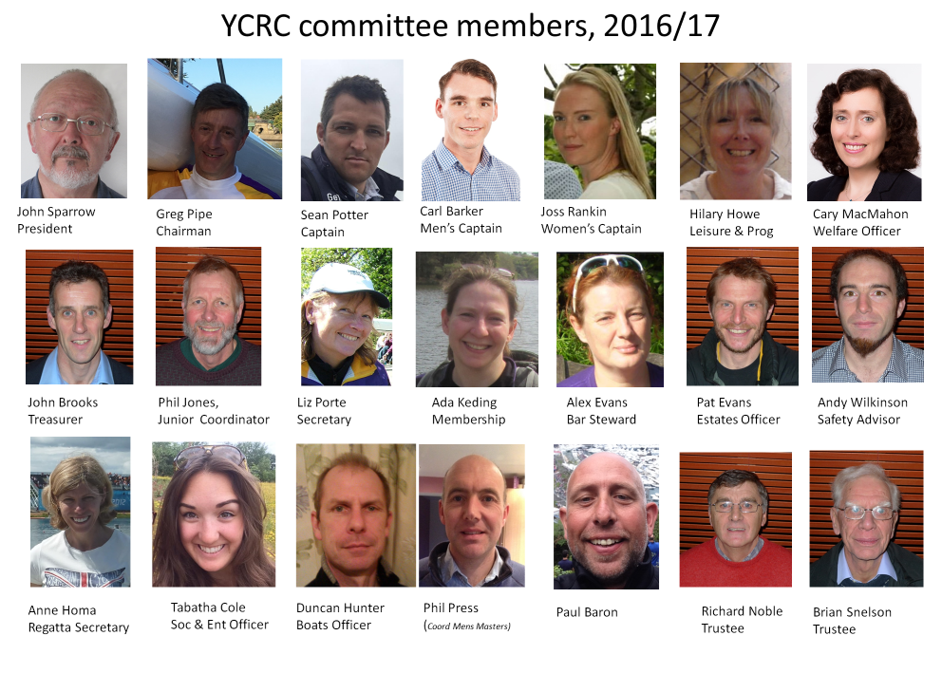

Sweep vs. Sculling
There are two different types of rowing available at York City Rowing Club – sweep rowing and sculling.
In sweep rowing – commonly simply referred to as ‘rowing’ – each rower has only one oar, with both of the rower’s hands being on that single oar. Rowing oars are sometimes called ‘sweep oars’.

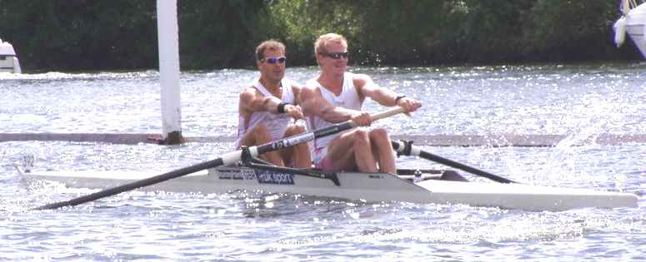
A pair, or 2-, in action.
When sculling, each rower has two oars, i.e. one in each hand. The oars used when sculling are often referred to as ‘sculls’.

A single scull, or 1x, in action.

An Overview of Boat Classes
There are a number of different types of rowing boats, defined not only by the number of rowers in the boat, but also whether the boat is a sweep boat or a sculling boat. A further sub-division is the inclusion of a coxswain (pronounced cox-n and often shortened to cox).
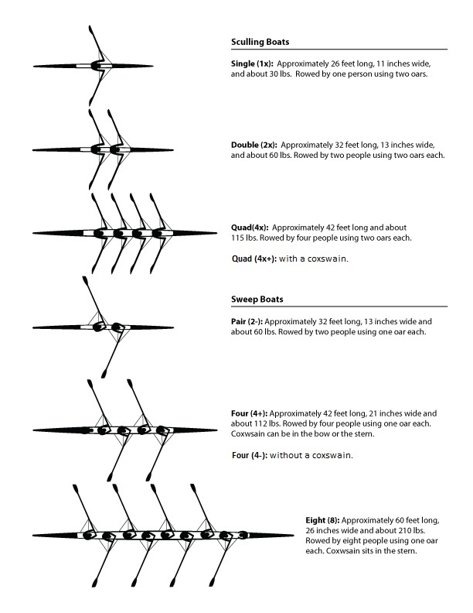

Terminology
There is a great deal of technical terminology surrounding rowing and it can be confusing to those new to the sport. The information below provides an overview of some of the terminology we use, but the best way to learn is to spend time with the more experienced members of the club. If in doubt………..feel free to ask!
Bow – the section of the boat to the rear of the rowers, i.e. facing the direction of travel.
Stern – the section of the boat to the fore of the rowers, i.e. opposite to the direction of travel.
Coxed – a boat class with a coxswain. Denoted by a ‘+’ after the boat class, e.g. ‘4+’.
Coxless – a crew boat without a cox. Denoted by a ‘-‘ after the boat class, e.g. ‘4-‘.
Strokeside / Bowside – the right hand side and left hand side of the boat respectively, as viewed from the perspective of the rower.
Slides – the ‘runners’ that the seat’s wheels roll up and down.
Rigger – a frame that projects outwardly from the hull of the boat for the purposes of holding the oar/scull and enabling the transmission of power in the water. Various types are available, including reverse wing riggers, standard wing riggers and traditional 3-stay riggers.
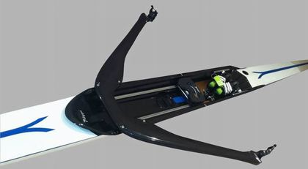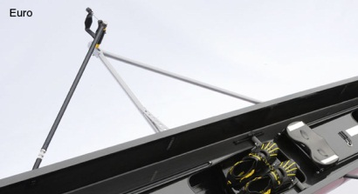
Carbon reverse wing rigger (left) and traditional 3-stay rigger (right)
Gate – the locking mechanism that sits atop the rigger, physically locking the oar/scull in place. All gates at YCRC are screw thread locking mechanisms. Also referred to as an ‘oarlock’.
Collar – also sometimes referred to as a button. This item fits over the sleeve and provides the pivot point for the oar, i.e. it’s axis.
Sleeve – a component of a sweep oar or scull. Located approximately 1/3 of the way down the length of the oar, the sleeve provides the mounting point for the button/collar.
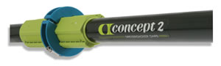
A sleeve and collar in place on an oar
Ergo – the indoor rowing machine, abbreviation of ergometer.

YCRC Venue Safety Plan

Boating and Landing Procedures
The boating and landing areas at YCRC are at the bottom of the steps immediately in front of the clubhouse doors. Owing to the restricted width of the boating area, different boating and landing procedures are employed for different craft. HOWEVER, boating is always conducted with the BOWS facing upstream.
Sweep boats
The boat is placed on the water, bow facing upstream, and held in position by a member of the crew in a manner to ensure the riggers are not damaged. Stroke side gates are opened and oars secured, and bow side rowers do the same whilst the boat is held securely in place. It should be noted that oars are placed in a NORMAL fashion – i.e. as you would row with them.
All bow side rowers then get in the boat and ensure gates are locked in place. Once all bow side oars are secure and the bow side rowers are able to lean into the steps the stroke side rowers may get in the boat. The cox can get in the boat at any point provided it is secure.
Sculling Boats
With Backstays
If the sculling boat has backstays, the boating procedure is as described above for sweep boats.
Without Backstays
If the sculling boat does not have backstays, i.e. not a traditional three-stay rigger, then the same procedure is followed as above, EXCEPT for the fact that the stroke side gate is reversed (turned TOWARDS the river) and the scull fixed in the reversed position.
When pushing away from the steps it is important to remember that your stroke side scull needs to come from you right hand side and be pushed past your body.
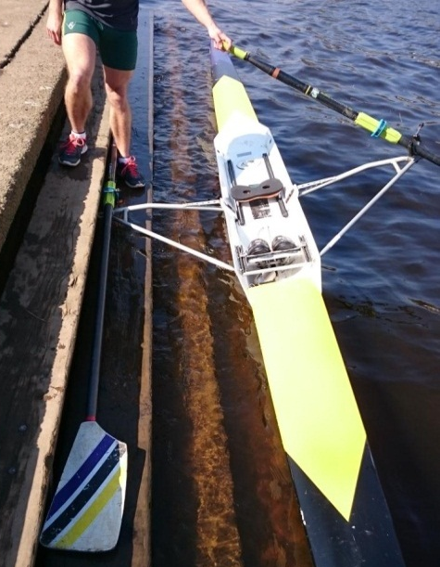
A more comprehensive guide to boating & landing can be found appended to the rear of this guide.

Clothing
When deciding what to wear whilst rowing, the most important consideration is that your choice of clothing MUST BE CLOSE FITTING. Wearing loose clothing whilst rowing presents risks from entanglement of oar/scull handles and trapping of clothing in the seat wheels.
The following types of clothing are inadvisable to be worn whilst rowing:
- Hoodies;
- Loose tracksuit bottoms;
- Baggy t-shirts; and
- Baggy shorts.
Whilst skin-tight lycra may not appeal to everyone, it is unfortunately the best type of clothing to be worn whilst rowing. It not only reduces the potential for entanglement but also tends to hold less moisture whilst exercising anaerobically and/or whilst it is raining.
For novices and new starters there is no immediate requirement to invest heavily in rowing specific clothing – close fitting standard sports clothing (as you might wear for running) will suffice. It is worth wearing several thinner layers rather than just one thick layer so you can keep yourself warm but not too hot.
Single scullers and anyone in the bow seat of a coxless boat should wear either a white or high vis top.
As you progress, you may want to purchase the following items of clothing:
- Lycra all-in-one (AIO). Mandatory for racing in club colours;
- Leggings;
- Splash jacket (waterproof layer); and,
- Gilet (warm/windproof layer)
- Pogies, overgloves designed for rowing.
Our current kit suppliers are Godfrey and there is a page on their website dedicated to YCRC – http://godfrey.co.uk/club/yorkcityrc. One off purchases can be very expensive, so we open a kit window once or twice a year for a bulk purchase. Liz Porte also keeps a stock of lycras as they are needed for racing – contact Liz on secretary@ycrc.co.uk. You can also get off the shelf rowing kit from several manufacturers – Godfrey, Powerhouse (http://www.powerhousesport.com), Stitch (https://www.stitchrowing.com/store).
For leisure wear, hoodies and poloshirts in club colours can be purchased from Teal – http://keal-teamwear.com/sportswear/clubs/york-city-rowing-club .

Safe Boating at YCRC
The changing river levels can make boating at YCRC a challenge on occasion. Newcomers may not always be familiar with the procedures required by our location.

Unless the river level is just below the concrete of the towpath (with no wooden steps showing), it is not possible to boat up with your oars perpendicular to your boat, as would be the case when boating from, say, a pontoon.

When the river is at ‘normal’ levels (≤ 0.75m) boating is done off the five sets of wooden steps in front of the boat house. Two of these sets are somewhat longer and should be prioritised for 4s and 8s if there are any of these boating or landing.

The following boating advice pertains particularly to single sculls with ‘ordinary’ aluminium riggers (with no backstays), but is generally true with some minor modification of other boat types.

Please always ask for help with boating up and landing if you are unsure of your skills.
Boats should be put on the water with bows facing upriver and into the stream (i.e. bowball to the left when facing the river). The stroke-side oar is put into the ‘bank-side’ oarlock first, as a means to lightly anchor the boat onto the step, with the handle and collar pointing upstream*.

The bow-side oar can then be put into the open ‘river-side’ oarlock and laid diagonally across the sax board (top edge of boat), handle resting on the step.

Getting into any boat requires good balance. Footwear should be removed and - standing adjacent the seat and facing the stern – push the seat to the ‘bow end’ of the runners. The left foot is then placed on the reinforced platform between the runners at front stops. Simultaneously bending to hold onto the riggers, (pulling up slightly on the left one and pressing down lightly on the right), step into the boat and settle onto the seat. The bodyweight should be kept over the stroke-side rigger and step at this point for additional security.

The bow-side oarlock should immediately be fastened and the spoon pushed out onto the water for stability. Adjustments to foot position should be made before putting on and fastening the shoes.

Setting off from the bank may then be effected by shifting the bodyweight lightly to bow-side and bringing the stroke-side oar handle to the front of the body, pushing away from the side with the spoon in the process.

On landing the boat at the steps, the procedure is reversed:

On the final (gentle) glide in, the bodyweight is shifted towards bow-side whilst the stroke-side handle is taken from the front of the body to behind and is pushed down slightly so the spoon comes level with the handle as it comes over the step*. When the rigger and pin are over the step, bodyweight can then be shifted over to stroke-side and kept there whilst the bow-side oarlock is unfastened and the rower gets out of the boat.

On the boathouse doors there are advisory notices on river conditions and river height guidelines. These should be referred to particularly in the case of the river level being above the towpath. Beginners should not go out if the towpath is under water. Guidance should be sought whenever necessary.

Boating from the concrete steps in front of the boat house, when permissible (see advisory notices), follows the same protocol as from the wooden steps, with special attention to maintaining balance and a gentle approach on landing to avoid boat damage.

Boating from elsewhere under the auspices of YCRC should follow local guidelines.

*Sweep boats or any boats with backstays will have the handle & collar pointing downstream on take-off and landing. Advice will be given by coxswains where appropriate.

Care of Equipment
The majority of equipment provided for club use at YCRC is purchased from the funds supplied by membership fees in addition to revenue raised by events such as regattas and head races. Owing to the high cost of most items, specifically boats and blades, it is critical that members take care of the equipment provided to them.
Sculling Blades/Sweep Oars
The instruction given on the safe boating and landing is the first port of call for preventing damage to blades/oars. A lack of attention during these activities can lead to snapped spoons and shafts.
In addition, a few points to remember:
- Do not leave blades/oars on the ground in the way of walking routes – place to the side of the steps when both boating and after landing;
- Take care when placing in the rack;
- Clean handles after use – this includes the removal of blood and dirt.
Boats
The purchase, repair and maintenance of boats is the club’s biggest expense, and failure to take care of the boats not only affects the club’s funds but also the potential use and enjoyment of the boats by other members.
- Always ensure you have sufficient people to lift the boat – if in doubt, ask and wait for assistance;
- When moving boats on and off the racks, pay particular attention to the fins of the boats above and below;
- Care should be taken to prevent damage to hulls by riggers of other boats. Attach tennis balls where available;
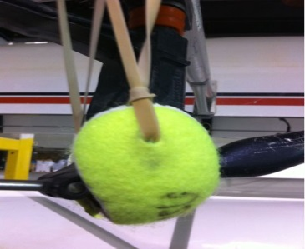
- For boats stored on the rollers on the floor – ensure that you push to rollers out of the way once you have lifted to boat to take it out. They pose a trip hazard if this is not done.
Pre and post-use checks
ALL equipment must be checked before and after use. Please report any defects to your squad captain and/or the boats officer, via the YCRC webpage (http://www.ycrc.co.uk/damage_report) or in person.

Additional Resources and How to Contact Us

British Rowing
http://www.britishrowing.org/
GB Rowing Team Office
British Rowing
6 Lower Mall
Hammersmith
London
W6 9DJ
Telephone: 020 8237 6767
Fax: 020 8563 2265

EA river level data
https://flood-warning-information.service.gov.uk/station/8208

Contact details:
Liz Porte, Club Secretary – secretary@ycrc.co.uk

